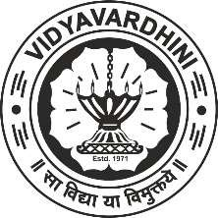 **Vidyavardhini’s College of Engineering & Technology, Vasai (W)**

**First Year Engineering**

**Academic Year: 2024-25**

**COURSE FILE**

|  |  |
| --- | --- |
| **Sr. No** | **Details of the Documents** |
| 1. | Class Time Table |
| 2. | Course objectives and Course outcomes |
| 3. | Syllabus |
| 4. | List of reference books |
| 5. | Lesson Plan |
| 6. | ICT tools and suggested on line courses |
| 7. | University Question paper with solution |
| 8. | Internal assessment paper with solution |
| 9. | Quizzes with solution |
| 10. | Curriculum gap identified and action taken |
| 11. | Notes and handouts |